**Writing Portfolio**

**Sophia Yu**

W6A

Summer Writing Course

With Mr. J at Teachall

July-August 2020, Beijing

**Index**

**I**

**Essays**

1. Essay 1: My Crazy Day

2. Essay 2: Making a Claim About a Historical Event

3. Essay 3: Using Variety When Introducing Narrator’s Thoughts

(Picture: Story Arc)

4. Essay 4: Narrative Writing Exercise

(Picture: Story Arc)

5. Essay 5: Writing from the Point of View of a Fictional Character

(Picture: Story Arc)

6. Essay 6: Analyzing Literature: Noticing the Author’s Choices in “How the Leopard Got His Spots” by Rudyard Kipling

(Picture: Story Arc)

7. Essay 7: Narrative Worksheet: Short Story

8. Essay 8: Letter to Captain

**II**

**Journal Entries**

1. Do you enjoy writing? Why or why not?

2. What is the one thing that you want to change about yourself?

3. What unexpected thing happened to you recently? Why?

4. What are three reasons why the global pandemic is good?

5. Write a 200-300-word summary of the article using at least three direct quotes.

6. Write your opinion of the situation. Do you agree or disagree with the writer? Why?

7. What character traits are most important to you? Why?

8. Why do some people struggle to do the right thing?

9. What does it mean to have integrity?

10. What is the hardest lesson you’ve ever had to learn? Why?

11. What is your favorite way to show your individuality? Why?

12. If you could take home any animal from the zoo as a pet, which would you choose?

13. What is your favorite way to show your individuality?

14. Who is your hero? What inspires you about this person?

**I**

**Essays**

[Essay 1: My Crazy Day: Draft 1]

**My Crazy Day**

Last summer vacation, I had a crazy day.

On vacation, I usually go to the Office Building and study with my friend. We always do our homework and read books, sometimes we play games, too. That day was no exception. I called her and I went to the Office Building to wait her. Then, she came,we started doing our homework.

The room was very quiet. I can even hear our breath, and the rustle of writing. The blue sky disappeared, replaced by dark clouds. The big wind blew the trees swing, and make whirring sound. “Hey!” I broke the silent: “Huh?” She looked up at me. “I think it will be rain”. I pointed outside and said. “Oh!” She put down her pen. “It will be okay.” “Yeah, maybe it’s only light rain.” I replied. We started studying again.

The wind blew harder and harder. The clouds went black, even we were in the room. I can still felt cold. All of a sudden. There were crackling from outside. Bean-size raindrops were falling from the sky, dancing and shouting. They hitting on the ground, trees, buildings and umbrellas. We both look up. “Oh no.” My friend gasped, “I have a umbrella.” I said quickly. “But I don’t have an umbrella!” She clapped her head. “Well then, we can use mine together!” I said happily. We need to go to the restaurant to have lunch at noon. “Maybe, we can wait here till the rain small.” She said hopefully. I think it’s a great idea so we keep studying.

However, we found the rain didn’t have any sign to stop, we were very hungry, so we must go to the restaurant now, under the rain.

We packed our things and went out. The world was different. Everything under the sky were gray and foggy. I feel I can touch the cloud because they were so close to us. The wind stroked our face, cold and comfortable. “Come on!” I opened my umbrella and waved to my friend.

We carrying the heavy schoolbag, holding the umbrella, and had to avoid puddles. The raindrop chuckled and jumping on our clothes, two of us were too big that the umbrella can’t cover the rain for us. Our shoes were full of water, and our pants were get wet to the skin, too. I’m so worried about my books and homework, because my schoolbag was too big that it was already out of the umbrella! My shoes creaked on the ground. I felt uncomfortable at all! It was terrible!

We speeded up the pace and tried to get the restaurant more quickly. Then, more and more water seeped in my shoes, my friend was complaining too. However, we can only move on now and keep going.

Finally, we got there. We are too tired, but now, we have to find a bathroom. We took off our shoes and socks, got some papers and cleaned our foot. We also used the paper to dry our socks. I can tell that was really fun!

We laughed and busy on drying our clothes, then we had a great lunch. I think that day was crazy but fun. Though the rain was not friendly, it was still an unforgettable experience. A rainy day, running under the rain with my friend and drying our clothes. It was a crazy day!

Word Count: 549

[Essay 1: My Crazy Day: Draft 2]

**My crazy day**

Last summer vacation, I had a crazy day.

On vacation, I usually go to the Office Building and study with my friend. We always do our homework and read books, sometimes we play games, too. That day was no exception. I called her and I went to the Office Building to wait for her. We started doing our homework when she came.

The room was very quiet. I could even hear our breath, and the rustle of writing. The blue sky disappeared, replaced by dark clouds. The trees were swinging in wind, and made whirring sound. “Hey!” I broke the silence, “Huh?” She looked up at me. “I think it will rain, “I pointed outside and said. “Oh!” She put down her pen. “It will be okay.” “Yeah, maybe it’s only light rain.” I replied. We started studying again.

The wind blew harder and harder. The clouds went black, though we were in the room, I can still feel cold. All of a sudden, there was crackling from outside. Bean-size raindrops were falling from the sky, dancing and shouting. They hitting on the ground, trees, buildings and umbrellas. We both looked up. “Oh no,” my friend gasped, “I have a umbrella.” I said quickly. “But I don’t have an umbrella!” She looked worried. “Well then, we can use mine together!” I said happily. We need to go to the restaurant to have lunch at noon. “Maybe, we can wait here till the rain get smaller,” she said hopefully. I thought that’s a great idea so we kept studying.

However, we found the rain didn’t have any sign of stopping. We were very hungry, so we have to go to the restaurant under the rain at once. We packed our things and went out. The world was different. Everything under the sky was grey and foggy. I felt I can touch the cloud because they were so close to us. The wind stroked our face, cold and comfortable. “Come on!” I opened my umbrella and waved to my friend.

We carried the heavy schoolbag, held the umbrella, and had to avoid puddles. The raindrops were jumping on our clothes, two of us were so big that our arms were out of the umbrella. Our shoes were full of water, and our pants were wet to the skin, too. I was so worried about my books and homework, because my schoolbag was too big that it was already out of the umbrella! My shoes creaked on the ground. I felt uncomfortable at all! It was terrible!

We tried to get the restaurant more quickly. Then, more and more water seeped in my shoes, my friend was complaining, too. However, we have to move on now and keep going.

Finally, we got there. We were too tired, but we need to find a bathroom. We took off our shoes and socks, got some papers and cleaned our feet. We also used the paper to dry our socks. That was really fun!

We laughed and dried our clothes, then we had a great lunch. I think that day was crazy but fun. Though the rain was not friendly, it was still an unforgettable experience. A rainy day, running under the rain with my friend and drying our clothes. It was a crazy day!

Word Count: 550

[Essay 2: Making a Claim About a Historical Event: Draft 1]

**Hiding**

At the end of 2019, a novel coronavirus began to sweep the world. Every country started to strictly control the epidemic.

On March 12, a Chinese woman who was living in America wanted to go back to China with her family. They took the flight cCA988 flew from Los Angeles to Beijing. A few hours after the flight took off, that women went to the steward and said that she felt suffocated, weak and slightly numb on her face. She also said that she did not travel with other people and had not taken any medicine before boarding, but had a short history of fever a week ago. The flight attendant took her temperature and isolated her from other passengers.

Then two hours before the flight landed at about 4:00 a.m. Beijing time on March 13, the woman went to the steward and said that she had been infected in the company where she worked in the United States. She had a fever in the United States and had taken anti-fever medicine before boarding. Her husband and children also traveled on the same plane, with seat numbers of 54K and 54l. The crew immediately reported the situation to the captain and arranged for her husband and children to sit in the isolation area.

After the crew took their temperature again, the temperatures of the whole family was normal. But when she and her family arriving in Beijing, she was diagnosed with novel coronavirus pneumonia, and more than 60 close contacts were isolated. In March 16th, her husband was diagnosed as novel coronavirus pneumonia. On June 1, 2020, she was arrested after recovering from the coronavirus.

Perhaps the woman thought reporting was very troublesome. She and her family want to go to China as quick as they can. It will spend too much time if they report it. Or, maybe she thought the pandemic was not as severe as everyone said. And she ate medicine so she thought she can get well by herself.

People in Beijing were very angry about that. They thought she was very selfish, and didn’t care about other people’s health. The other people consider that her behavior can be forgiven, because everyone wants to go to the safe place quickly.

I think She didn’t do the right things, either. She did it just for herself and her family, and it’s not correct at all. If she told the truth to the officer, and isolated herself from others, she wouldn’t make others need to be isolated. It probably would have taken a long time, but it would have been good for everyone.

In the end, this story has a bright side. First, the customs office can pay more attention to people who come back to China from other country. Second, it is a warning to other people not to do that like her. People not only need to protect themselves like by washing hands and doing exercise, but should also to be concerned about other people.

Word Count: 499

[Essay 2: Making a Claim About a Historical Event: Draft 2]

A woman hides the truth

At the end of 2019, a novel coronavirus began to sweep the world. Every country started to strictly contain the epidemic. At this time, we should not violate the instructions of the state and do what we want to do without authorization. But there are always some people who will have a fluke, and the things they do bring inconvenience to many people.

On March 12, a Chinese woman living in America wanted to go back to China with her family. They took the flight CA988 from Los Angeles to Beijing. A few hours after the flight took off, that lady went to the steward and said that she felt suffocated, weak and slightly numb on her face. She also said that she did not travel with other people and had not taken any medicine before boarding, but had a short history of fever a week ago. The flight attendant took her temperature and isolated her from other passengers.

Then Two hours before the flight landed at about 4:00 a.m. Beijing time on March 13, the woman went to the steward and said that she had been infected in the company where she worked in the United States. She had a fever in the United States and had taken anti fever medicine before boarding. Her husband and children also traveled on the same plane, with seat numbers of 54K and 54l. The crew immediately reported the situation to the captain and arranged for her husband and children to sit in the isolation area.

After the crew took their temperature again, the temperatures of the whole family were normal. But when she and her family landing in Beijing, she was diagnosed with novel coronavirus pneumonia, and more than 60 close contacts were isolated. On March 16th, her husband was diagnosed with novel coronavirus pneumonia. On June 1, 2020, she was arrested after recovering from the coronavirus.

.

Perhaps the woman thought reporting was very troublesome. She and her

family wanted to go to China as quickly as they could. It spend too much time if they reported it. Or, maybe she thought the pandemic was not as severe as everyone said. And she ate medicine so she thought she will get well by herself.

People in Beijing were very angry about that. They thought she was very selfish, and didn’t care about other people’s health. Other people consider her behavior could be forgiven, because everyone wants to go to a safe place quickly.

I think she didn’t do the right thing, either. She did it just for herself and her family, and it’s not correct at all. If she told the truth to the officer, and isolated herself from others, she wouldn’t make others need to be isolated. It probably would have taken long time, but it would have been good for everyone.

In the end, this story has a bright side. First, the custom officer can pay more attention to people who come back to China from other countries. Second, it is a warning to other people not to do like her. People not only need to protect themselves like by washing hands and doing exercise, but should also concerned about other people.

Word Count:534

[Essay 3: Using Variety When Introducing Narrator’s Thoughts: Draft 1]

**Climbing a Hill**

On July 16th ,2020, my parents and I went climbing hill. I don’t know why I can climb on the hill top, even I stayed at home half a year, but I really did it.

We woke up at 5:40 in the morning, then we drove our car at the foot of the hill, I was so hungry that I could eat anything, so we ate breakfast as quickly as we could on a bench. After that, we started climbing.

At first, it was quite easy for all of us, our pace had always been faster. I was nearly ready to climb on the hill’s top in two hours, because it’s not very difficult. However, climbing the hill is not an easy thing to do at all. My mom started panting, my dad was very surprised, he said, “Are you really so tired?” I agreed with my dad. I’m not panting and I didn’t have leg pain yet, it’s too early to feel tired, wasn’t it?

But I should have leg pain right now, because I had a dancing lesson yesterday and it always hurt me so much when I wake up next morning. And we were already climbed a bit, so why my leg didn’t feel pain? I tried to think this straight, but I need to pay attention to the road under my feet.

We keep climbing the hill. My dad was in the front. I was in the middle, and my mom was behind me. Sometimes I quicken my pace and climbed the hill side by side with my dad, sometimes I slow down and walk with my mom. When my mom was tired, I stopped to had a rest with her, and then my dad was gone. My mom and I keep going, after a while, we saw my dad waiting for us not far away. I don’t know why, but I’m not really tired when we climbed halfway up the hill. I couldn’t think it clearly how did I do it.

We sat on a stool beside a big tree to have a rest about six minutes. My mom thought we can’t sit too much, or we won’t be able to walk, so, we started climbing again.

I felt a little bit tired, but I’m just short of breath. Of course, I can stick to it. There’s no doubt about it. “Hey, I still have some dates in my bag,” my dad turned around and said to us. So, we found a place and enjoyed the delicious dates. My dad ate a lot of dates in five minutes, but I was too busy wondering about why I didn’t get the leg pain, so I just ate three dates.

“Hiccup!” It’s from my dads’ mouth. I looked at him happily. “Hiccup!” He belched again. “Ha-ha” I laughed with my mom. Perhaps he ate too many cold dates and ate them quickly.

The higher the hill, the steeper it is. But it also told us it’s not very far to the top. We took a break every 40 step, my legs were starting to ache, too. My dad had been belching all the way, which really added a little bit of fun to me. And we didn’t try to eat the remaining dates.

Then, here we go, we went on the top of the hill, it’s took us 140 minutes. I’m very surprise because the top of the hill was much closer than I thought, but it still took a lot of energy. Now was the time to take photos. We always take photos when we climbed on the top of the hill every time. I can’t believe that I can still climbed on the top, we stayed at home all day during the pandemic, no playing with my friends, no running or jumping. I’m very happy to climbing the hill this time.

Word Count: 648

[Essay 3: Using Variety When Introducing Narrator’s Thoughts: Draft 2]

**Climbing a Hill**

On July 16th ,2020, my parents and I went climbing XiangShan. I don’t know why I could climb to the top of the hill, even I stayed at home for half a year, but I really did it.

We woke up at 5:40 in the morning, then we drove our car to the foot of the hill, I was so hungry that I could eat anything, so we ate breakfast as quickly as we could on a bench. After that, we started climbing.

At first, it was quite easy for all of us, and we kept a fast pace. I was nearly ready to climb to the hill’s summit in two hours, because it’s not very difficult. However, climbing the hill is not an easy thing to do at all. My mom started panting and my dad was very surprised. He said, “Are you really so tired?” I agreed with my dad. I wasn’t panting and I didn’t have leg pain yet, it was too early to feel tired, wasn’t it?

But I should have had leg pain right now, because I had a dancing lesson the day before and it always hurt me so much when I wake up the next morning. And we had already been climbing a while, so why didn’t my legs feel sore? I tried to think this straight, but I needed to pay attention to the path under my feet.

We keep climbing the hill. My dad was in the front. I was in the middle, and my mom was behind me. Sometimes I quickened my pace and climbed the hill side by side with my dad, sometimes I slowed down and walk with my mom. When my mom was tired, I stopped to have a rest with her, and then my dad was gone. My mom and I keep going. After a while, we saw my dad waiting for us not far away. I don’t know why, but I was not really tired when we climbed halfway up the hill. I couldn’t think it clearly how did I do it.

We sat on a stool beside a big tree to have a rest for about six minutes. My mom thought we can’t sit for too long, we won’t be able to walk. So, we started climbing again.

I felt a little bit tired, but I was just short of breath. Of course, I could stick with it. There was no doubt about it. “Hey, I still have some dates in my bag,” my dad said to us turning around. So, we found a place to enjoyed the delicious dates. My dad ate a lot of dates in five minutes, but I was too busy wondering about why I didn’t have the sore legs. So, I just ate three dates.

“Hiccup!” The sound came from my dads’ mouth. I looked at him happily. “Hiccup!” He belched again. “Ha-ha” I laughed with my mom. Perhaps he ate too many cold dates too quickly.

The higher the hill, the steeper it was. But it also told us it was not very far to the top. We took a break every 40 steps and my legs were starting to ache. My dad had been belching all the way, which really added a little bit of fun for me. And we didn’t try to eat the remaining dates.

Then, we went on the top of the hill, it’s took us 2 hours and 40 minutes. I was very surprise because the top of the hill was much closer than I thought, but it still took a lot of energy. Then was the time to take photos. We always take photos we climb whenever the top of the hill.

I couldn’t believe that I could still climb to the top because I stayed at home all day during the pandemic, no playing with my friends, no running or jumping. Although I was a little tired after climbing this time, I had a sense of achievement. But it will be easier and easier to climb.

Word Count: 691

[Story Arc: Essay 3: Using Variety When Introducing Narrator’s Thoughts]

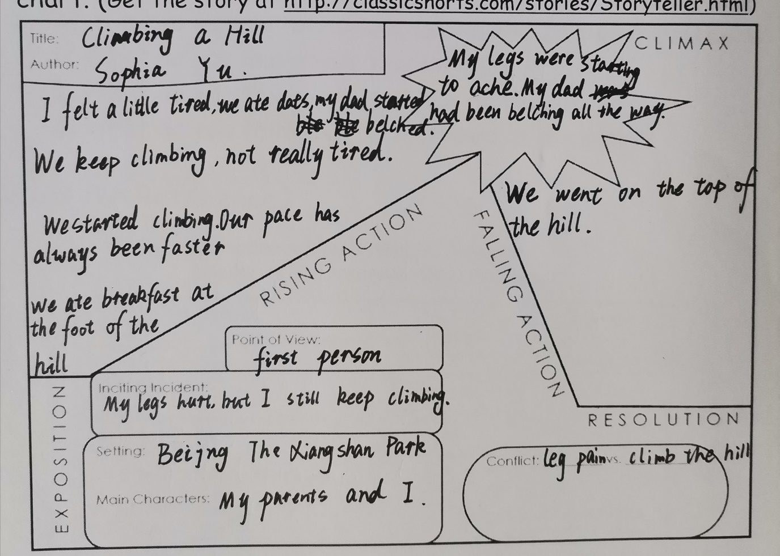

[Essay 4: Narrative Writing Exercise: Draft 1]

**A Wonderful Journey**

Last winter vacation, our school organized graduate study activities. We can go to Finland or Singapore. I chose Finl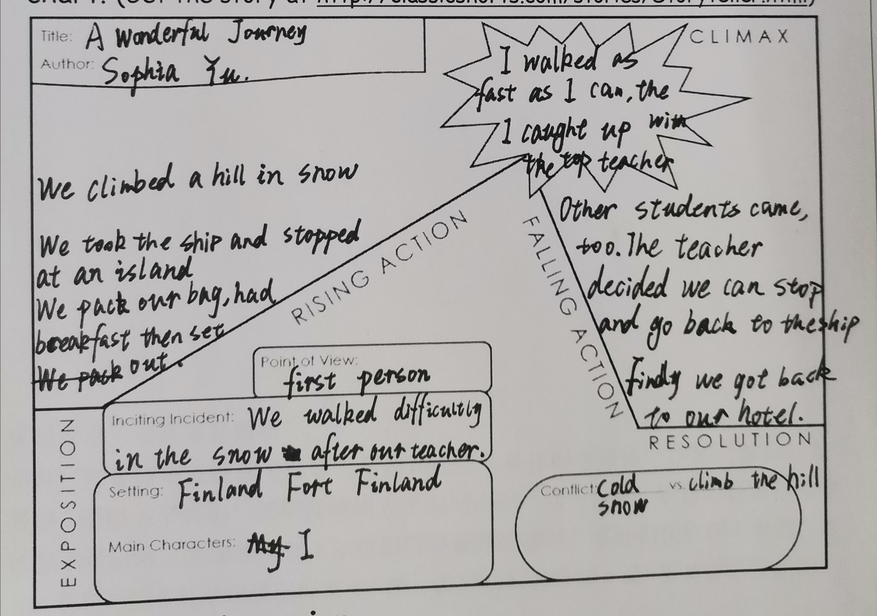and because I can go to Singapore anytime with my family. But Finland is very far away from here and it’s very cold, so I want to go there.

At fourth day we went there, we already visited a lot of beautiful things there, but there are still many sceneries we didn’t see yet. That day our teacher decided to take us to see Fort Finland. We need to take the ship first, then we should walk to the Fort Finland. Oh, that must be tiring. But we packed our bag, ate breakfast, then we set out.

We took the bus to the wharf and then we got on the ship. The ship was really big, it had three floors, and the third floor was the fascinating deck. Teachers allowed us can go on deck, so everybody ran on the deck excitedly. The wind gently blowing on my face, warm and comfortable, brought a trace of salty fresh. On the edge of the vast sea, there were some simple low buildings. The breeze swept over the calm water, ripping with waves. It was great to be on the boat! I’m deeply moved.

We stopped at an island. The teacher said Fort Finland is in here. Finland is Finland, the cold wind blowing my face, everywhere was full of white shiny snow. Teachers leaded us went to the Fort Finland. The branches of trees were shaking in the air alone by the roadside. We walked about half an hour, then we arrived Fort Finland. It’s very big and beautiful. There was a bit of royal nobility without losing the dignity of frontier fortress. I thought after visiting here, I could go back to the hotel and lie down comfortably. But the teacher had plan to asked us to take a walk around the island. So, we have to follow the plan.

At first, we just walked on the road, talking and playing. But then, we have to climb the hill. The hill was covered with thick snow. I tried to step on it, the snow went right over my knee! It was the first time I’ve seen such a thick snow. My classmate tried it as carefully as I did, with indecisive eyes. However, a teacher who in the front of us fast forwarded. Then I have to go on. I followed the teacher and tried to pick up speed. The snow under my feet was very soft like marshmallow. I’ll make a snowman with my friends, if we weren’t following the teacher.

I walked as fast as I could. when I finally caught up with the top teacher, I found I’m the fasted student. A few students came, too, but none of them were my classmate. I raised my head. The blue sky was so clear that had no single cloud. The teacher, some students and I were waiting other students by some steps. After a while, my friends came, and other students of course.

Our teacher decided we can stop here and go back to the ship; all the students agreed with that. But we still need to walk back! My friends and I played some games during walking, and that was fun. Finally, we went back to our hotel! I’m tired but it was really a wonderful journey!

Word Count:568

[Essay 4: Narrative Writing Exercise: Draft 2]

**A Wonderful Journey**

Last winter vacation, our school organized graduate study activities. We could choose to go to either Finland or Singapore. I chose Finland because I could go to Singapore anytime with my family. But Finland is very far away from here and it’s very cold, so I wanted to go there.

At fourth day we went there, we already visited a lot of beautiful things there, such us the White church 、Red church but there were still many sceneries we didn’t see yet. That day our teacher decided to take us to see Fort Finland. We needed to take the ship first, then we should walk to the Fort Finland. Oh, that must be tiring, I thought. But we packed our bags and ate breakfast, then set out.

We took the bus to the wharf and then we got on the ship. The ship was really big, it had three floors, and the third floor was the observation fascinating deck. Our teachers allowed us to go on the deck, so everybody ran on the deck excitedly. The wind gently blowing on my face, warm and comfortable, brought a taste of salty freshness. On the edge of the vast sea, there were some simple low buildings. The breeze swept over the calm water, ripping with waves. It was great to be on the boat! I was deeply moved.

We stopped at an island. The teacher said Fort Finland is here. Finland is Finland, the cold wind blowing my face, everywhere was full of white shiny snow. Our teachers lead us to Fort Finland. The branches of the trees were shaking in the air alone by the roadside. We walked about half an hour, then arrived at Fort Finland. It was very big and beautiful. There was a bit of royal nobility without losing the dignity of frontier fortress. I thought after visiting it that I could go back to the hotel and lie down comfortably. But the teacher had planned to ask us to take a walk around the island. So, we had to follow the plan.

At first, we just walked on the road, talking and playing. But then we had to climb the hill. The hill was covered with thick snow. When I tried to walk on it, the snow went right over my knees! It’s the first time I’ve seen such thick snow. My classmate also tried to walk on it as carefully as I did, with indecisive eyes. However, a teacher in front of us sped up. Then I had to go on. I followed the teacher and tried to quicken my pace. The snow under my feet was very soft like marshmallows. I thought I would like to make a snowman with my friends.

I walked as quickly as I could. when I finally caught up with the top teacher, I found I was the fastest student. A few other students also came, but none of them were my classmates. I raised my head. The blue sky was so clear that had not a single cloud. The teacher, some students and I were waiting for the other students by some steps. After a while, my friends came, along with the other students, of course.

Our teacher decided we could stop here and go back to the ship. All the students agreed with that. But we still needed to walk back! My friends and I played some games while walking, which was fun. Finally, we went back to our hotel! I was tried but I saw the beautiful Fort Finland, learned its ancient history, it was really a wonderful journey!

Word Count: 560

[Story Arc: Essay 4: Narrative Writing Exercise]



[Essay 5: Writing from the Point of View of a Fictional Character: Draft 1]

**A Girl Who Wants to Be a Witch**

“Expelliarmus!” I raising my “wand” and shouted. “What are you doing Lucy? “A short woman broke in through the door asked discontentedly. “Sorry mom, I’m just practicing the disarming charm,” I answered excitedly. “Oh, fine, “my mom gave me a helpless look.

I’m a “Harry Potter Fan”, I read Harry Potter since I was eight. At first, my favourite house was Gryffindor, only the bravest can go. But now, I changed my mind, I likes Ravenclaw. Ravenclaw is the symbol of wisdom. If you ask why I love Harry Potter, I can’t tell, maybe I was a witch in my last life.

“Lucy, dinner is ready, come and eat,” my mom walked in my bedroom. I was reading Harry Potter again. My mother sighed and went back to the dining room. “OK!” I answered quickly but didn’t move at all. I had a weird habit. When I read Harry Potter, I must wear Hogwarts uniform. The long black robe made me very comfortable, and it feels like I’m a witch, a student from Hogwarts.

“I want to go to Hogwarts!” I yelled to the book, but I knew I can’t, because I didn’t get admission letter with an owl from Hogwarts when I was 11. I can only be a muggle. “I’m 13 right now, if I don’t practice hardly, I’ll be left behind by witches of my own age,” I raised my “wand” by my right hand, my left hand was holding the book and I opened her mouth, “stupefy!”

“What are you doing?” A strange voice sounded in my ears. I found my book was gone, and a boy sprawled in front of me. “Are you okay? Can you move?” I crouched down beside him and tried to pull him up. “Yes, but why did you do that? I didn’t even touch you,” the boy stood up and looked at me angrily. I froze. This boy wore black glasses, and a scar on his forehead.

“So, are you really Harry Potter? I asked carefully, I can’t believe my eyes. “Yeah,” the boy answered with impatient. “No, I mean, real Harry Potter, not the cosplayer,” I explained hopefully, and looked around. My bedroom was replaced by the road, old buildings and a few people. “What?” I was very surprise. “What did you mean? Real Harry Potter? My name is Harry James Potter, a student from Hogwarts. Of course, also named by the Boy Who Lived.” He said to me. When he was saying the last sentence, it seems to be a little bit squeezed out of his mouth. With a little helplessness in his tone. I found my self was not surprised in my imagination. “Oh, okay then, so where are we now, and why are you laying on the road when I meet you?” I asked Harry Potter.

Harry stared at me, “Are you a Death Eater? What’s your name?” “Of course, I’m not! My name is Lucy.” I was a little confused. “Well, we are in London now, and you just appeared in front of me and casted a stunning charm on me.” Harry explained slowly. “What? But ……” I suddenly realized I was in a real Wizarding World! “I’m going to the Diagon Alley, do you want to go with me?” “Sure!”

We went to the Leaky Cauldron and pointed the bricks in order. The brick wall 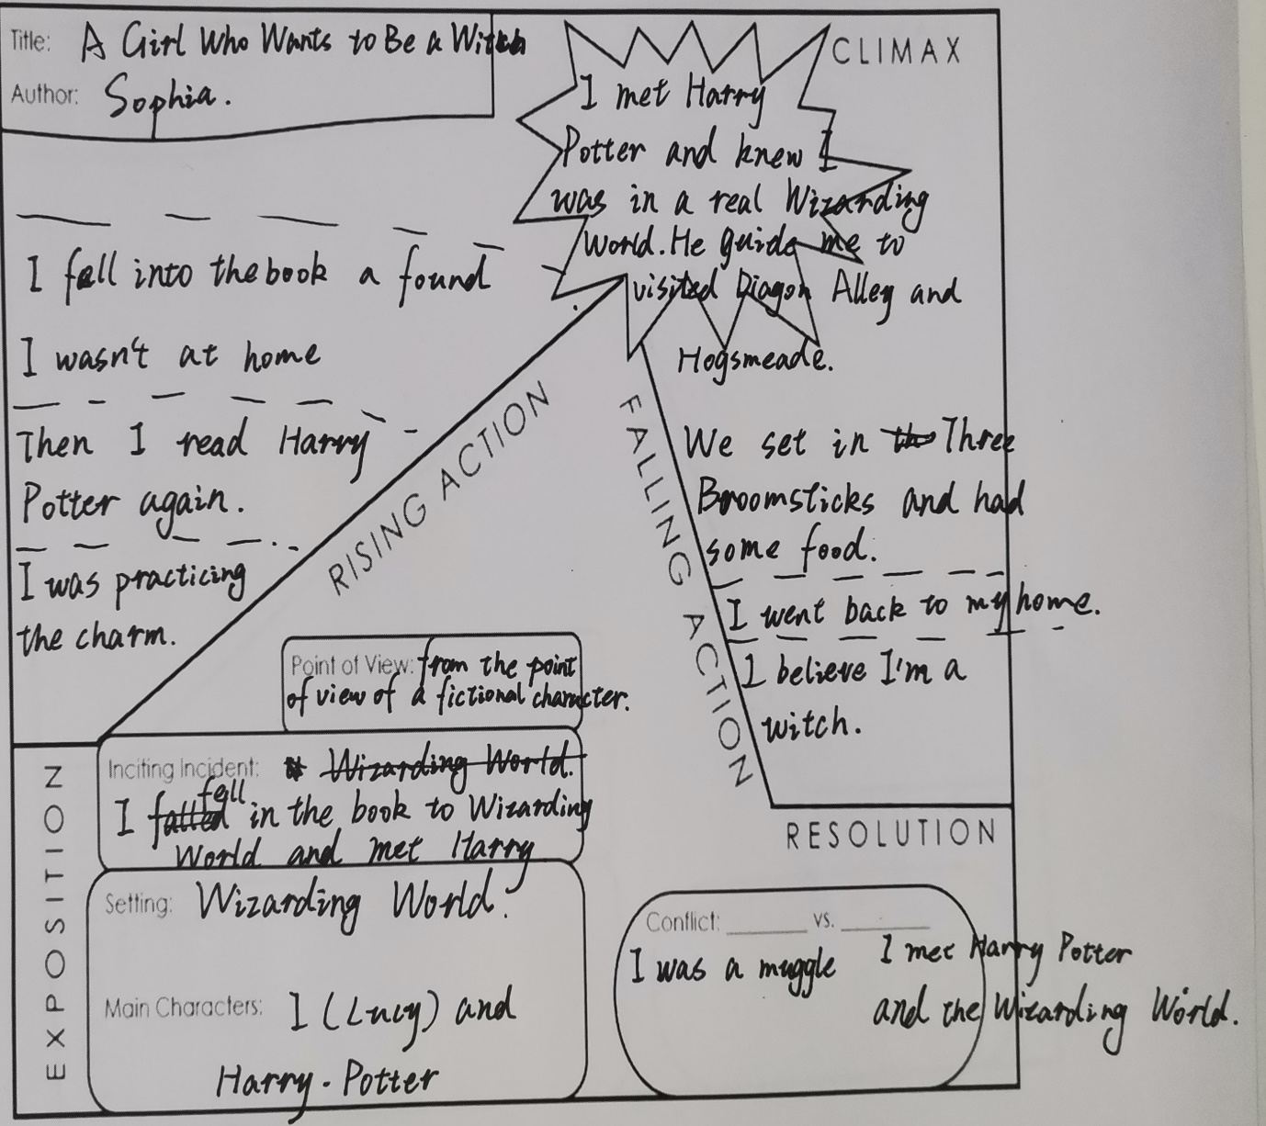opened. “Welcome to Diagon Alley, “Harry said to me. I saw the Diagon Alley was as same as what the book described. The Cauldron shop, the shops selling robes, and the store selling brooms and much more. Harry bought some new robes and decided to guide me to look around in Diagon Alley. We talked about each other and had a great time. I used Harry’s Galleons, Sickles, Knuts to buy some things, and I gave Harry some muggle money. We used broomsticks to go to Hogsmeade. I drank a lot of butterbeer, and took many candies from Honeydukes. “What about Hogwarts? Can I go there?” I asked excitedly. Harry shook his head, “Sorry, but I don’t think so.” I was a little disappointed. We had a rest at Three Broomsticks and had some food. “I think it is time to leave,” I was very reluctant. “Sorry?” Harry had some doubts. “Oh, no!” I felt I was spinning fast. “I have to go!” I shouted to Harry, “Bye!” He didn’t know what to say. “wait!” He suddenly yelled “What is the cosplayer?” “I’ll explain it to you next time.” The Three Broomsticks and Harry were gone. I was back to my room.

“Lucy, dinner is ready, come and eat.” My mom walked in my bedroom. I blinked，“OK,”I stood up and followed my mom. But I wasn’t hungry at all.

From this moment on, I was more convinced that I was a witch. So, I practiced more and more hard. I knew it wasn’t dream that I met Harry and the Wizarding World, because I still had some chocolate Frogs in my pocket.

Word Count: 835

[Essay 5: Writing from the Point of View of a Fictional Character: Draft 2]

[Story Arc: Essay 5: Writing from the Point of View of a Fictional Character]



[Essay 6: Analyzing Literature: Noticing the Author’s Choices in “How the Leopard Got His Spots” by Rudyard Kipling: Draft 1]

**Analysis of *How the Leopard Got His Spots***

In this story *How the Leopard Got His Spots*, the author Rudyard Kipling makes many choices, such as scene description, characterization and forming a turning point to create a world that the story happened. A man and a yellow Leopard live in an old hot place, the hunt animals to live. One day animals grew blotchy and stripy, so that the man and Leopard couldn’t see them, a Baboon told them they need to change, they listened a Baboon’s advice to change their skin, the Leopard grew some black spots, the man’s skin grew blacker, then they lived happily ever afterward.

Firstly, he chooses scene description, it makes the story’s scene more vivid and tell the background of the story. For example, the High Veldt is: the seclusively bare, hot, shiny High Veldt, where there was sand and sandy-coloured rock and seclusively tufts of sandy-yellowish grass”, it describes an old, hot, colourful place which called the High Veldt where the main character and animals live.

Then, he chooses characterization, this can tell the main characters in the story, and their features. For example, “there was an Ethiopian with bows and arrows (a seclusively greyish-brownish-yellowish man he was then), who lived on the High Veldt with Leopard, and the two used to hunt together the Ethiopian with his bow and arrows”, we can know that the man and the Leopard are the main character in this story, and they always hunting animals to live.

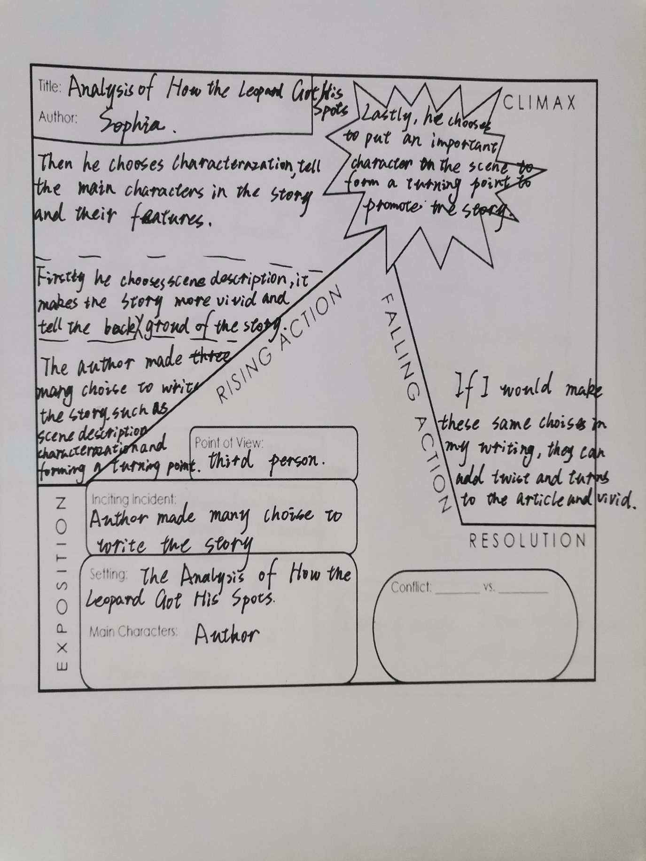Lastly, he chooses to put an important character on the scene to form a turning point. In this way, the development of the story is promoted through the communication between the character and the main character, forming a turning point. Like the author designed a clever Baboon to warn the man and the Leopard to change their skin’s colour, they combined their experience with the Baboon’s advice, and they eventually changed the colour of their skin.

In conclusion, the author Rudyard Kipling uses choices scene description, characterization and chooses to put a character who is very important for the development of the story. This story is about a Leopard got his black spots and a man changed his skin-color blacker for hunting animals when they couldn’t see other animals because they all changed their skin colour. If I would make these same choices in my writing, they can add twist and turns to the article and vivid.

Word Count:400

[Essay 6: Analyzing Literature: Noticing the Author’s Choices in “How the Leopard Got His Spots” by Rudyard Kipling: Draft 2]

[Story Arc: Essay 6: Analyzing Literature: Noticing the Author’s Choices in “How the Leopard Got His Spots” by Rudyard Kipling]



[Essay 7: Narrative Worksheet: Short Story: Draft 1]

**A Horrible Roller Coaster**

A summer vacation when I was 10, my family and I went to Disney World in Orlando, it was really a wonderful journey.

We arrived there by bus in the morning, then we waited a moment till the Disney World open to go inside. I saw many familiar things in the park, like Snow White and Micky Mouse. We took a picture in the front of the castle; the castle was so beautiful. We played some small roller coasters, my dad and I thought they were exciting, but not scary, my mom had different idea, she thought they were terrible. So, when I want to try some terrifying game project, my dad went with me, and my mom found a place to wait us.

I walked with my parents in many game projects. I saw a big yellow building with a gigantic guitar across from us. I felt it was an exciting game to play, so I decided to try it with my dad. “Dad, that looks like a lot of fun, let’s go and have a look,” I pointed it and asked my dad. There were a lot of people standing in line, which reinforces the idea that I think it’s very popular. The two of us patiently lined up for more than an hour, and finally we were almost there.

We started to watch what this was for. But then, we saw a horrible scene, every six people in black seats, with heavy protective gear, suddenly rushed out at an unimaginable speed after 30 seconds. Within five seconds, they disappeared into the dark tunnel, and there was some faint scream. My dad and I were stunned. “This is so horrible!”I said to my dad, staring. “So, do you want to play it? Or we could go out,” my dad asked me. “It’s hard to wait in line for such a long time. Is it better to have a play?” “Okay then.” My dad and I waited in the line till it’s our turn.

The staff arranged for us to get int the small black car, and taught us to take safety equipment. I started nervous, so did my dad. When all of us are ready, the seat that we set rushed out like an arrow. My hair flew over my head, and the wind blew on my face, it made my want to close my eyes, but I didn’t.

I tried to keep my eyes wide open, and for a moment int the dark, I wasn’t even sure if my eyes were still opening. About ten seconds I saw some beautiful lights winking in the dark, and the seat was now going uphill smoothly. I thought it was not as terrible as I thought at that time. Good times don’t last long. All of a sudden, a sense of weightlessness surrounded my whole body, it was our seats on the downhill! I heard so many people screaming that I couldn’t tell if I was screaming, it’s a bad feeling. There was endless darkness everywhere. Despite the colourful lights, the track of the roller coaster in front of me could not be seen, so I know nothing about what was going to happen next. You know I was afraid of the roller coaster that turned around the whole circle. So, when I play in the Disney World, I will deliberately avoid all the roller coaster that will turn around. Don’t’ meet them here!

Music came to my ears again, but I had no time to enjoy it. The ups and downs of the roller coaster made me closed my eyes, hold on to the handle and waited to stop. I tried to open my eyes and felt that the roller coaster was a little smoother, but then, the seat was so startled moving uphill that I felt like my head was going to explode. Not o mention that, my glasses were surprisingly about to come out of my face, and one of the leg of the glasses had left my ear already. I quickly calmed down, one hand holding the handle tightly, the other hand simply took the glasses down and put them in my hand to prevent them from falling down. I’m not sure, but I thought I was going through a complete circle on a roller coaster.

I closed my eyes again and holding my glasses. “Hey!”I turned my head, it was my dad’s voice.“You are quiet quick, I thought your glasses were fell down, if that really happened, it’s okay. We still have spare glasses, right?”I nodded, I saw he took the glasses off, too. The rest of the time, I still closed my eyes and occasionally look up at the light and listened to music, he roller coaster seem not really terrible now.

Finally, the roller coaster was over, dad and I walked out of the yellow building with limp legs. We saw a child come out crying, perhaps she was very afraid. “It is because I don’t know what it is that I dare to try. Now I know what terrible thing it is I dare not play it again,”my father said .“So, do you want to play this next time?”I joked, “Of course not!” My father replied with some fear. We came to my mom’s side, and I began to embellish her with descriptions of our experiences.

Word Count: 911

[Essay 7: Narrative Worksheet: Short Story: Draft 2]

[Essay 8: Letter to Captain: Draft 1]

[Essay 8: Letter to Captain: Draft 2]

**II**

**Journal Entries**

[Journal 1: Do you enjoy writing? Why or why not?: Draft 1]

[Journal 1: Do you enjoy writing? Why or why not?: Draft 2]

[Journal 2: What is the one thing that you want to change about yourself?: Draft 1]

[Journal 2: What is the one thing that you want to change about yourself?: Draft 2]

[Journal 3: What unexpected thing happened to you recently? Why?: Draft 1]

[Journal 3: What unexpected thing happened to you recently? Why?: Draft 2]

[Journal 4: What are three reasons why the global pandemic is good?: Draft 1]

[Journal 4: What are three reasons why the global pandemic is good?: Draft 2]

[Journal 5: Write a 200-300 word summary of the article using at least three direct quotes.: Draft 1]

[Journal 5: Write a 200-300 word summary of the article using at least three direct quotes.: Draft 2]

[Journal 6: Write your opinion of the situation. Do you agree or disagree? Why?: Draft 1]

[Journal 6: Write your opinion of the situation. Do you agree or disagree? Why?: Draft 2]

[Journal 7: What character traits are most important to you? Why?: Draft 1]

[Journal 7: What character traits are most important to you? Why?: Draft 2]

[Journal 8: Why do some people struggle to do the right thing?: Draft 1]

[Journal 8: Why do some people struggle to do the right thing?: Draft 2]

[Journal 9: What does it mean to have integrity?: Draft 1]

[Journal 9: What does it mean to have integrity?: Draft 2]

[Journal 10: What is the hardest lesson you’ve ever had to learn? Why?: Draft 1]

[Journal 10: What is the hardest lesson you’ve ever had to learn? Why?: Draft 2]

[Journal 11: What is your favorite way to show your individuality? Why?: Draft 1]

[Journal 11: What is your favorite way to show your individuality? Why?: Draft 2]

[Journal 12: If you could take home any animal from the zoo as a pet, which would you choose?: Draft 1]

[Journal 12: If you could take home any animal from the zoo as a pet, which would you choose?: Draft 2]

[Journal 13: What is your favorite way to show your individuality?: Draft 1]

[Journal 13: What is your favorite way to show your individuality?: Draft 2]

[Journal 14: Who is your hero? What inspires you about this person?: Draft 1]

[Journal 14: Who is your hero? What inspires you about this person?: Draft 2]